- ARCHITECTURAL DIAGRAM

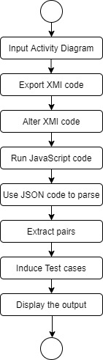
- Input Activity Diagram

Activity diagrams are generally the traditional flowchart that differ in the sense of the additional activities that are performed by the system. Activity diagrams are so just not the exact flowcharts as they have some additional capabilities that include branching, parallel flow, swim lanes, etc.
A clear understanding of the core parts of an activity diagram is a must to justify the diagram and its significance. Also, knowing the core elements help develop the diagram accurately. The main element of an activity diagram is the activity that is a function performed by the system. After identifying the activities, the next step is to understand how they are associated with constraints and conditions.
Before drawing an activity diagram, we should identify the following core elements −
- Activities
- Association
- Conditions
- Constraints
Once the above-mentioned elements are identified, we need to make a mental layout of the entire flow. This mental layout is then transformed into an activity diagram using StarUML.
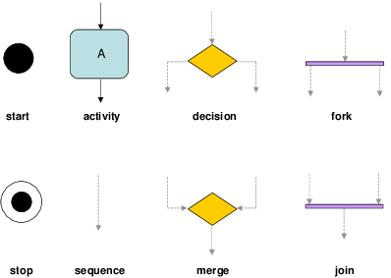
- Export XMI Code.

In the mentioned application, StarUML is used for drawing an activity diagram and to export the XMI code corresponding to the same. StarUML is a sophisticated software modeler aimed to support agile and concise modeling.StarUML has XMI export as its key feature and support to import and export XMI (XML Metadata Interchange) whichmakes it a more useful software. It is based on XMI 2.1 and UML 2.0 metamodel. XMI (XML Metadata Interchange) is for metadata interchange among various software modeling tools.
Export XMI
Select the menu: File > Export > XMI Export (v2.1)

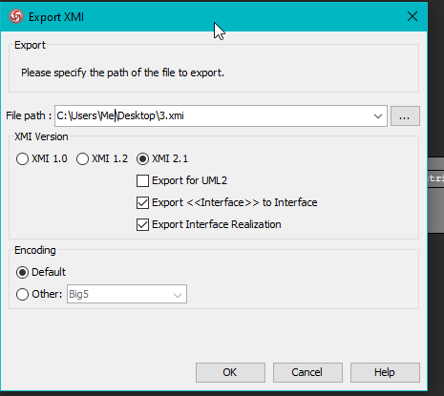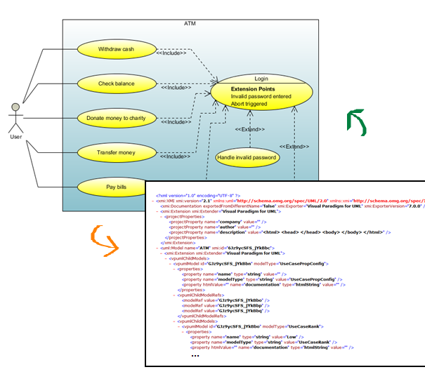

Understanding the XMI

The XMI header

Although it mostly specifies an algorithm, XMI also defines a few tags and attributes.
XMI is always the root element. It must have an xmi.version attribute (valid versions are 1.0, 1.1, 1.2, and 2.0).

XMI.header is a placeholder for information on the model. Its most important children are XMI.documentation and XMI.metamodel.
XMI.documentation holds end-user information as these children elements (whose names are self-explanatory):
- XMI.owner
- XMI.contact
- XMI.longDescription
- XMI.shortDescription
- XMI.exporter
- XMI.exporterVersion
- XMI.exporterID
- XMI.notice
- XMI.metamodel records the metamodel to which the XMI algorithm has been applied.
- XMI.content contains the actual model.
- xmi.id and xmi.idref are attributes for encoding links: xmi.id is an element identifier that must be unique; xmi.idref is a reference to an element by its identifier.

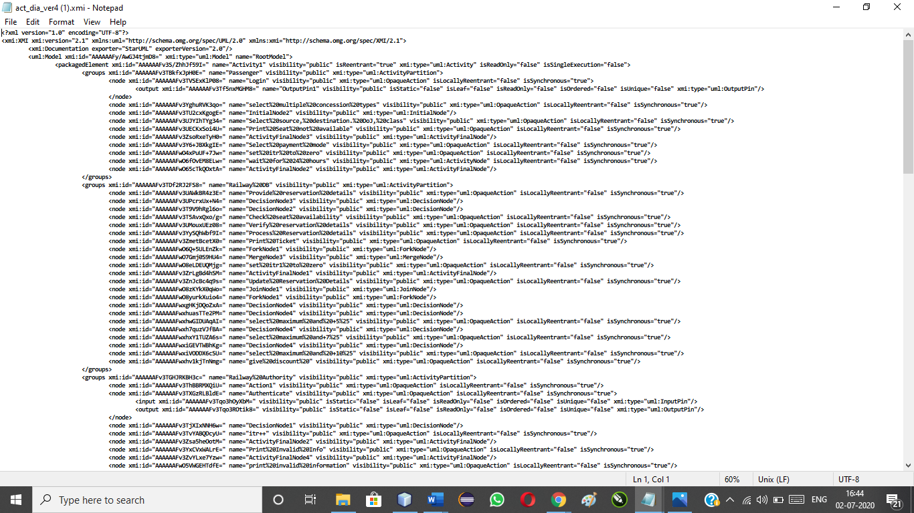
Figure 1:the XMI code for the mentioned application.

- Alter the XMI code

It is necessary to group the tags under the same tag to get access of all of them to make is more reachable. The minor changes that are done are quite visible in the further screenshot of the modified XMI code.

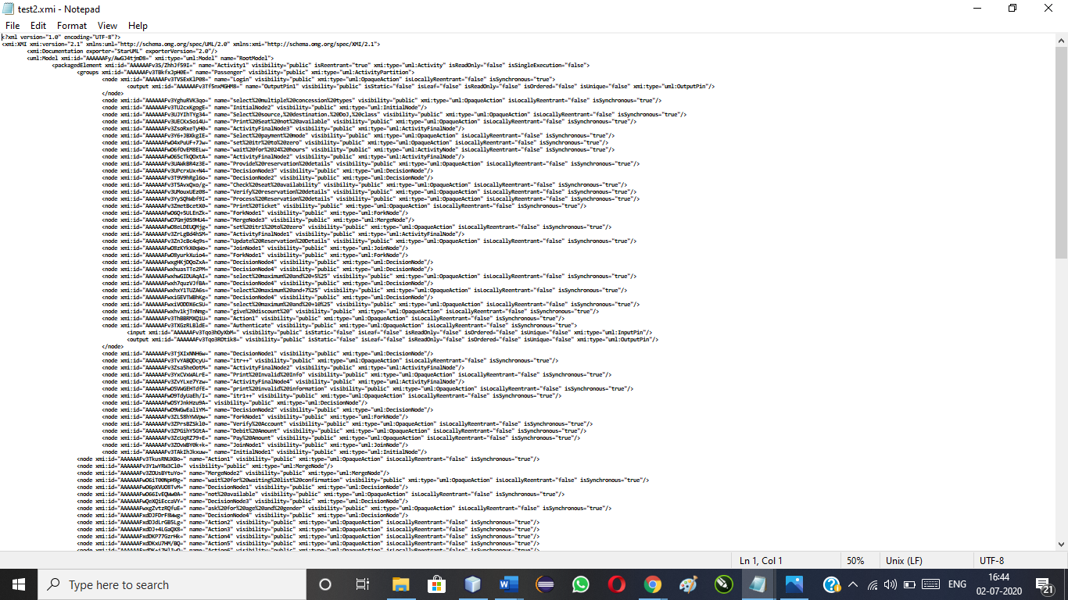
Figure 2:Modified XMI code.
Our JavaScript code consists of an function called the parameterValusMapping() function. Here in this function we find out various Parameters from the XMI code we got and to these parameters there are values associated. These values that correspond to some parameters are also found out using the same function. The algorithm of the function is as follows:

parameterValuesMapping() function :

1. Mark parameter “p” to the node with xmi:type = uml:OpaqueAction
2. Get the xmi:id of that node.
3. Traverse the edges_array and find the edge withxmi:id of node = source of edge.
4. Consider target of that edge.
5. Again traverse the edge_array, and find all the edges such that target of edge = source of edges. Collect ‘name’ attribute of all matching nodesand push into ‘v’.
6. The 'v' array contains all the values of corresponding parameter.
7. push 'p' and 'v' in finalConfig array.
8. repeat.

- Conversion of XMI to JSON using Javascript.

constconvertXMITOJSON = () => {
return new Promise((resolve, reject) => {
xml2json(
{
input: "./test.xmi",
output: "./check.json",
},
function (err, result) {
if (err) {
console.error(err);
reject(err);
} else {
resolve(result);
}
}
);
});
};

The above code converts a defined XMI code to JSON code. The above code snippet is written in JavaScript Language. It is necessary converting a XML code to a JSON code in order to make use of the feature of JSON of preserving the code in pairs which help us in delivering output in the required format.

- Parse the JSON code

In JavaScript we use the method JSON.parse().
- The method parse() is primarily used to return a JavaScript object from the string that is parsed.
- The string that has to be parsed using JSON.parse() should be in a json format.
- The JSON.parse() method can transform the result with a function but only optionally.

Parameter | Description
string | Compulsory. A string written in JSON format is mandatory.
reviver function | Optional. A function used to transform the result. The function is called for each item present. Any nested objects are transformed before the parent of the current.  - If the function returns a valid value, the item value is replaced with the transformed new value  - If the function returns undefined, the item is deleted from the record

JSON.parse() takes a string in JSON format and transforms it into a JavaScript object.

JSON stands for JavaScript Object Notation.

JSON is extremely lightweight data-interchange format for exchange of data between server and client which is quick and easy to parse and generate.
JSON just like XML is also a text-based format which is easy to write and very easy to understand for both humans and machines, but unlike XML, JSON data structures occupy a less amount bandwidth than their XML versions. JSON is based on two primitive structures:

Parsing JSON Data in JavaScript
One can easily parse JSON data received from the web server using the JSON.parse() method with the help of Javascript. This method namely JSON.parse() parses a JSON string and constructs the JavaScript value or object described by the string. If the given string is not in a given JSON format, you will get a syntax error.
Now, we can simply use this JavaScript method to convert this JSON string into a JavaScript object and access individual values using the dot notation (.).

Parsing Nested JSON Data in JavaScript
JSON objects and arrays can also be nested manner. A JSON object usually contains other JSON objects, arrays, nested arrays, arrays of JSON objects, and many more.
All the parameter-value pairs are stored in .csv file that are extracted through the JSON file and output is displayed on the console in the form of parameter value pairs and if guard conditions are present the pairs are presented in two-way or three-way test-cases.

